Appendix B: Referral Procedures
STUDENT IDENTIFICATION
“School districts shall develop systems designed to identify pupils with disabilities beginning at birth, pupils with disabilities attending public and nonpublic school, and pupils with disabilities who are of school age and are not attending any school. The district’s identification system shall be developed in accordance with the requirement of nondiscrimination and included in the district’s total special education system plan.” [M.R. 3525.0750]
1. Child Find Activities: SWWC and member districts shall conduct ongoing activities designed to identify students who may require special education. These activities shall include, but are not limited to:
a. Community Outreach: Member districts, in cooperation with SWWC and regional Interagency Early Intervention Committees (IEICs) shall prepare and disseminate information regarding available services and referral procedures for students, ages birth through 21, who may be in need of special education. Each district shall insure that such information is available in the native language of its non-English speaking residents. Dissemination may be via public news releases (i.e., newspapers, radio, etc.), school bulletins, brochures, speaking engagements to parent and civic groups, etc. Records of news releases, speaking engagements and copies of disseminated information shall be maintained as appropriate.
b. Coordination with Referring Agencies: District and SWWC personnel shall provide information regarding available services, referral procedures, forms, etc. to all community agencies, groups and individuals who have contact with students ages birth through 21. Community agencies and groups shall include, but are not limited to:
1) Physicians, clinics and hospitals;
2) Public health agencies;
3) Public and private social service agencies;
4) Public and private schools;
5) Head Start, preschools, nurseries and day care facilities;
6) Mental health service agencies; and
7) Local chapters of parent and lay associations
c. Review of Student Progress: All students shall have their progress reviewed to determine if they may be in need of special education. This shall include, but is not limited to:
1) A periodic review of student records, including the results of group testing, by classroom teachers; and
2) A review of the education record and/or interview with the parent of each new student by the building principal (or designee).
2. Model of Educational Service Delivery - GSL Public Schools:
Scientific, Research Based Interventions (SRBI) within Multi-Tiered Systems of Support (MTSS)
Background Information for Determining the Eligibility of Students with Specific Learning Disabilities
Minnesota has two options for determining eligibility for special education services.
- The first option is use of data determining below grade-level performance, lack of response to well-designed interventions and a weakness in a basic psychological process that is consistent with low achievement.
  - Some may refer to this as lack of response to intervention or identification through a Multi-tiered System of Supports (MTSS).
  - Districts do not have to apply or be approved to use eligibility criteria under a MTSS system; however, they must document their process in the Total Special Education System (for more information, see Minnesota Rules, part 3525.1341, subpart 4).
- Many schools maintain use of discrepancy criteria for instances where data and application of an MTSS system are not in place and implemented with fidelity. “Specific Learning Disabilities.” Minnesota Department of Education, https://education.mn.gov/MDE/dse/sped/cat/sld/
GSL recognizes that the traditional use of the discrepancy model for SLD identification has been called into question, and is no longer considered best practice. When IDEA was reauthorized in 2004, the default use of the traditional discrepancy model for SLD identification was replaced with the option to use other models. Currently, only 39 states permit the use of this model, while 11 states forbid it. One drawback of the discrepancy model includes that it often identifies kids too late. Students with learning differences often struggle in the early grades, but they rarely show a large enough discrepancy on test scores to be “officially” identified with a learning difference. This can lead to a “wait to fail” situation: Kids don’t receive help until after they’re doing poorly in school. In addition, a severe discrepancy evaluation doesn’t suggest what kind of help students need. Test results may indicate there’s a problem, but the scores alone don’t provide detailed information about performance and what specific kinds of instruction and support kids need. “The Discrepancy Model: What You Need to Know.” Understood.org, https://www.understood.org/articles/en/the-discrepancy-model-what-you-need-to-know
GSL’s MTSS model is based on recommendations from the Minnesota Department of Education (MDE). MDE defines MTSS as follows:
A Multi-tiered System of Supports (MTSS) relies on multiple tiers of instruction that work together as a safety net to prevent school failure. The critical features of this school-wide framework include:
- Assessments: A system of assessments to screen, monitor the progress of and provide summative data about students.
- High-quality, evidence-based instruction: Utilized for students at multiple intensity levels.
- Core instruction: All students receive core instruction as part of the general curriculum. It must be standards based, of high quality and delivered with fidelity to increase the likelihood that the majority of students in a class are making progress and can become proficient in grade-level standards by the end of the school year.
- Tier 2 or supplemental interventions: a second level of supports for students who are not on track to be proficient.
- Data-based decision making: School leaders and teachers use data obtained through the MTSS framework process to improve organizational supports and instruction and to make decisions about students at risk of not meeting grade-level expectations.
Effective implementation of the MTSS framework ensures that all students receive evidence-based instruction that leads to proficiency in the academic areas to which it is applied. In Minnesota, there are three related statutes supporting districts’ use of the critical features of MTSS:
- Reading Proficiently No Later Than the End of Grade 3 (Minn. Stat. § 120B.12).
- Alternative Delivery of Specialized Instructional Services (Minn. Stat. § 125A.50).
- Alternate Instruction Required Before Assessment Referral (Minn. Stat. § 125A.56).
The Minnesota Department of Education (MDE) advocates the use of MTSS to increase the number of students meeting grade-level standards and graduating with skills for further education and work careers. The majority of MDE’s work with MTSS is connected to implementing the Minnesota K-12 Academic Standards with fidelity and building additional intervention supports to increase student achievement for all students. “Multi-tiered System of Supports (MTSS).” Minnesota Department of Education, https://education.mn.gov/mde/dse/mtss/
GSL recognizes that the purpose of MTSS is not to define which students are in need of special education; but to provide high quality instruction to all students, to monitor their progress, and to effectively and efficiently identify and address skill gaps toward grade-level standards using evidence-based interventions and progress monitoring. Special education and related services are not seen as separate entities in this model, but rather are provided within the context of the overall MTSS system. This system is based on high quality core instruction which is aligned with developmental skill progression, aligned with grade-level standards, and implemented with fidelity.
GSL also recognizes that if a student is indeed found eligible for special education, the use of evidence-based interventions and progress monitoring must also be prioritized, especially in light of data regarding the general lack of progress students make toward grade-level standards even when given an Individualized Education Program (IEP).
GSL’s Model of Education Service Delivery: Multi-Tiered Systems of Supports (MTSS)
The GSL MTSS model utilizes three pillars of practice, each implemented across a multi-tiered (four-tiered) continuum of service delivery:
- Assessment
  - Benchmarks, Screeners, Formative and Summative and Progress Monitoring
- Instruction with Data Collection
  - Whole, Strategic Differentiated Learning Group and/or Individual
- Problem-Solving & Data Analysis within Each of the Four Tiers
  - Problem Solving Protocol
    - Step 1: Define the Problem
    - Step 2: Analyze the Problem and Develop a Plan
    - Step 3: Implement the Plan
    - Step 4: Evaluate the Plan
The GSL MTSS model utilizes a variety of teams of professionals at each of the four tiers:
- Professional Learning Communities (PLC), Tiers 1 & 2
  - Grade level or specialist teams
    - Principal, RtI Specialist, SEL Specialist, and other staff join as needed
    - Meets at least twice weekly
  - SITE Team
    - Principal, one representative from each PLC (grade level, specialists, special education), RtI Specialist, SEL Specialist, paraprofessional
    - Meets monthly
  - PRO team (PBIS/RC/Olweus)
    - Positive Behavior Intervention & Supports (PBIS), Responsive Classroom (RC), and Olweus Bullying Prevention Program (Olweus)
    - Principal, one representative from each PLC (grade level, specialists, special education), RtI Specialist, SEL Specialist, school counselor, paraprofessional
    - Meets at least monthly
- Solution Focus Team (SFT), Tiers 2 & 3
  - Principal, RtI Specialist, SEL Specialist, School Counselor, School Psychologist
    - Meets at least twice monthly (in each building)
- Special Education Assessment Team (SEAT) & Special Education, Tier 4
  - Special Education Case Facilitator, School Psychologist, and relevant disability area staff
    - SEAT meets at least twice monthly (in each building); Special Education Team meets at least twice weekly (PLC); SEAT meets with special education team at least once monthly (in each building)
GSL’s MTSS model focuses on the early identification of students at risk of not meeting grade level standards through school-wide assessments. This MTSS model provides targeted, high quality and effective evidence-based interventions in order to successfully address student’s identified skill gaps.
MTSS is a general and special education, collaborative school-wide system that provides instruction, support, enhancement and intervention to all children and youth. Because special education and related services are not seen as separate components in this model, but are within the context of the overall MTSS system, data collected during the MTSS process may be used as part of the eligibility determination process for special education.
The GSL MTSS model encompasses features of assessment, instruction, data collection, problem-solving and data analysis across four tiers of service delivery. This incorporates all learning: academic, behavior, and social/emotional needs of all students.
Tier 1
- GSL provides a core instructional program in the general education classroom which is aligned with educational standards, provides an appropriate level of rigor, and has a high probability of bringing the majority of students (with the goal of at least 80%) to acceptable levels of proficiency. Achievement is measured through school-wide data collection. This data is utilized by grade-level PLC’s to make adjustments in their instruction, curriculum and environment ensuring that the majority of their students are on track to meet the targeted standard.
Tier 2
- GSL uses Strategic Differentiated Learning (SDL) provided to students for whom the core instruction was not effective to drive meaningful educational progress toward the targeted standard. This instruction takes place in the general education classroom, is based on grade-level standards, is systematically scaffolded, and is differentiated to meet a broad range of student needs. Grade-level PLC’s are utilized to identify specific students who are not responding to core instruction and to identify their needs. Identified students are instructed in flexible skill groups (often 3-6 students) or one-to-one by classroom teachers. Students participating in Strategic Differentiated Learning will be recorded on the “PLC-Strategic Differentiated Learning Group Progress” sheet maintained by each classroom teacher/grade level PLC. Interventions may include those from Wonders, Press, Read Naturally, Rocket Math, Check-In-Check-Out, etc. Data is collected and instruction is checked for fidelity and adjusted based on student achievement toward the standard. Fidelity checks are completed by school administration, the RtI Specialist, the SEL Specialist, or another certified teaching peer. When data indicates a student is making gains and has met the target, the student will be exited from the intervention. When data indicates a student is not making progress (rate of improvement is not closing the gap toward the target), adjustments to the intervention should be made. After a minimum of 3-6 weeks, a referral to Tier 3 should be considered. For students considered high-risk (based on the school-wide data), progress is monitored weekly using the appropriate measure for the targeted skill (ex., reading fluency will be measured using CBM-R; target behaviors will be measured using CICO).
Tier 3
- If a student is not making adequate progress in Tier 2 (rate of improvement is not greater than that of peers, thus closing the skill gap), the classroom teacher informs the student’s parent and obtains their input. The classroom teacher then completes the Tier 3 form and gives this form to the RtI Specialist or the SEL Specialist. The student is added to the SFT agenda. The RtI Specialist and/or the SEL specialist meets with the referring teacher. The SFT then analyzes all information and data collected. The SFT may recommend or complete additional individual diagnostic screeners (for example, the Feifer Assessment of Reading, the Phonological Awareness Screening Test, Functional Assessment Interviews) to guide placement into a skill-appropriate research-based intervention. The student’s parent is notified in writing (passive consent) by the RtI or SEL Specialist that their child will be receiving targeted interventions. The targeted services for Tier 3 may include standard published intervention programs (i.e., Read Naturally GATE, Level Literacy Intervention, Soar to Success, Number Worlds, Daily Behavior Report Cards, Check and Connect, etc.), or other research-based protocols. The specificity, intensity (group size and/or frequency), and minimum of 12 data points over minimum of 7 weeks of the instructional interventions are identified to increase an individual student’s rate of progress. All targeted interventions will be checked periodically for fidelity by the RtI Specialist, SEL Specialist, or other trained staff. Progress monitoring data will be collected at least weekly. The RtI Specialist and/or the SEL Specialist will meet with each student’s teacher monthly to review progress. Teachers and parents may additionally ask for their student’s data at any time. Teachers will share student progress with parents at conferences (minimally).
Tier 4
- When a minimum of two evidence-based interventions are documented (including baseline data) and implemented with fidelity (and in the case of SLD, for a minimum of 12 data points over a minimum of seven weeks each), but a student did not make adequate progress in Tier 3 (rate of improvement is not projected to reach the target), the SFT may refer the student to the Special Education Assessment Team (SEAT) for consideration for a comprehensive special education evaluation. The SEAT will consider all relevant data in light of special education exclusionary factors. The classroom teacher will again contact the parents to obtain their input, and to inform them about a potential special education evaluation. If a special education evaluation is deemed necessary, the SEAT will then obtain formal parent permission. Intervention data may be used as part of the determination of eligibility for special education. Because of the high stakes nature of identifying a student as having a disability, it is critical that data collected during each tier of the MTSS process is valid, reliable, and accurately documented. If a Specific Learning Disability (SLD) is suspected, data must support an inadequate rate of progress with a minimum of 12 data points over a minimum of seven weeks. This data must reflect a minimal rate of improvement, that progress is not maintained, that performance is below expectation, and that achievement is below the fifth percentile.
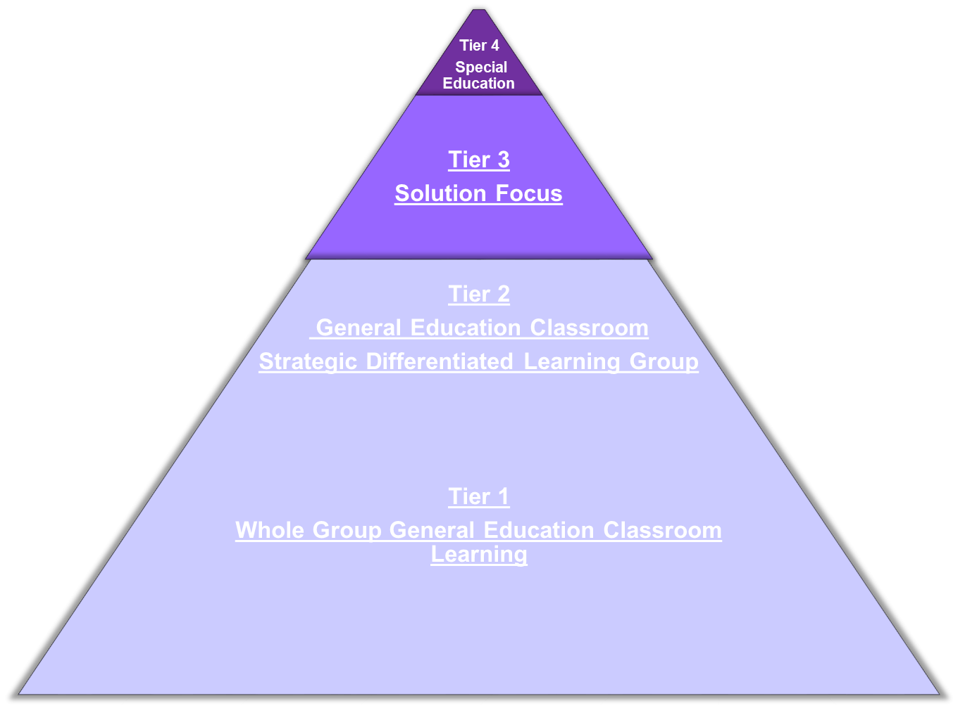
Tier 4:
5% of Students
Tier 3:
15% of Students
Tier 1 & 2:
80% of Students

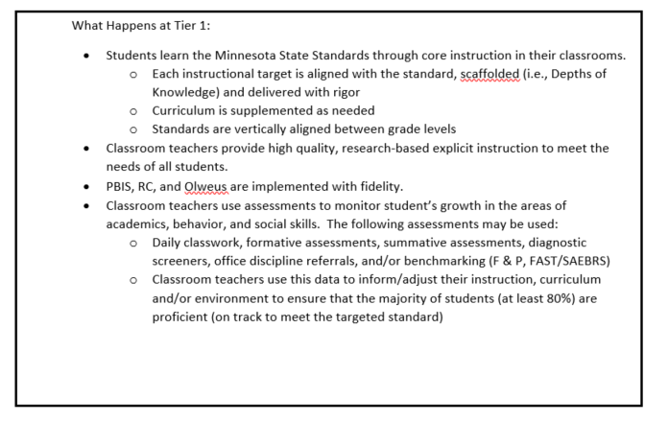
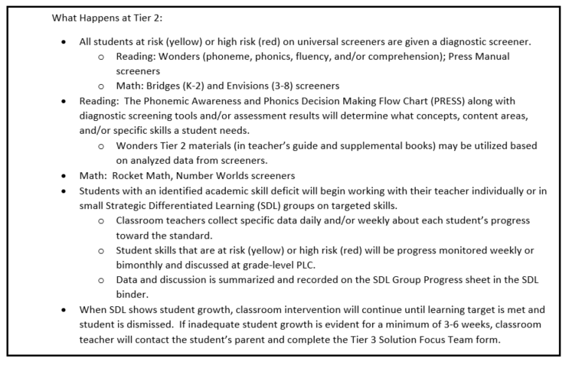
Tier 1 & 2:
80% of Students
Tier 4:
5% of Students

Tier 3:
15% of Students

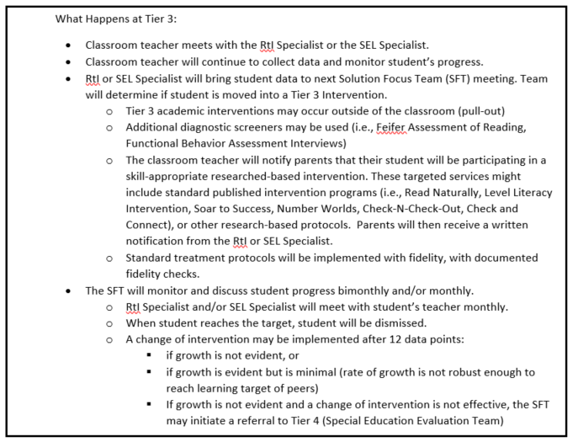

Tier 1 & 2:
80% of Students

Tier 3:
15% of Students
Tier 4:
5% of Students

Tier 4:
5% of Students

Tier 3:
15% of Students

Tier 1 & 2:
80% of Students

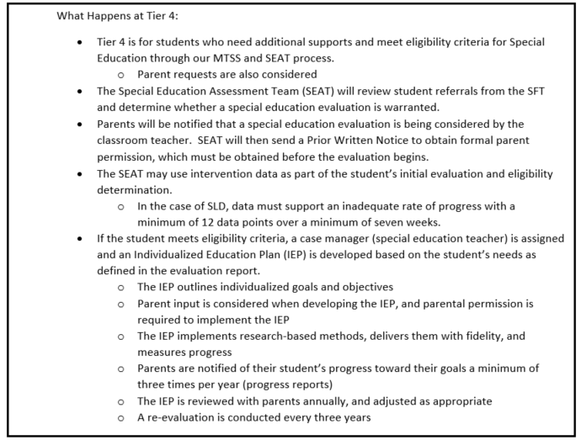

Key Definitions:
Response-to-Intervention (RtI): Evaluating whether a student is benefiting from a scientifically-based instructional program through frequent and continuous measurement of performance and data-based decision-making. Special education services may be provided to those students who meet eligibility criteria due to a failure to respond to well-designed interventions, experiencing low achievement, and do not demonstrate evidence for exclusionary criteria.
Scientific Research Based Intervention (SRBI): This is a term often used interchangeably with terms like evidence based or research based intervention or RtI. Instructional techniques, interventions, or curriculum that are based on studies that (a) use empirical methods, (b) include rigorous and adequate data analyses, (c) use measurements or observational methods that provide reliable and valid data, (d) employ experimental or quasi-experimental designs, (e) are replicable, and (f) undergo a formal peer review process.
Multi-tiered System of Support (MTSS): This is a term often used interchangeably with terms like evidence based or research based intervention or RtI. A Multi-Tiered System of Supports (MTSS) in Academics relies on multiple tiers of instruction that work together as a safety net to prevent school failure. (http://education.state.mn.us/MDE/dse/mtss/index.htm)
Problem-Solving Model: Solutions to instructional and behavioral problems are generated by a team through a Five Step process: (1) Problem Identification, (2) Problem Analysis, (3) Plan Development, (4) Plan Implementation, and (5) Plan Evaluation.
Standard Treatment Protocol: Requires the use of the same empirically validated treatment for all children with similar problems. It is generally delivered in small groups and is often very structured. Often standard-treatment protocols are multi-faceted to meet aspects of the area of concern. Progress is monitored frequently and instruction is adjusted, based upon student response.
Criterion-referenced Targets: Performance on benchmark assessments, using General Outcome Measures. These targets are pre-defined for each benchmark assessment used at each grade level (fall, winter and spring).
Norm-referenced Targets: Norm-referenced targets provide information about how a student performed relative to some comparison group. For example, a student who scores in the 50th percentile performed as well or better than 50% of the students in the comparison group. This score would likely be considered in the “average” range of students nationwide, depending on the purpose of the assessment.
Curriculum-Based Measurement (CBM): A reliable and valid assessment system for monitoring student progress in basic academic skill areas such as reading, writing, spelling, and mathematics. CBM procedures, including test administration, scoring, and interpretation, are standardized. The content of the CBM tests may be drawn from a specific curriculum or may represent generalized outcomes for a student at that grade level. In either case, CBM test content represents important, global outcomes for the year and not just an individual objective or series of objectives representing current instructional lessons. Students are given short alternate assessments of these important grade-level skills frequently across the school year and their scores are plotted on a graph. Teachers are then able to use these CBM scores in a formative way to gauge student progress over time.
Universal Screening/Benchmark Assessments: Regular assessments (typically standardized and correlated with summative assessments such as MCAs) that are administered to all students 2-3 times per year. Results can be used to determine whether Tier 1 instruction is meeting the needs of most (80% recommended) students, as well as to identify early on which specific students are not on track to be proficient on summative assessments (ex., FastBridge probes).
Progress Monitoring: A scientifically based practice used to assess students’ academic performance on a regular basis and to evaluate the effectiveness of the instruction they are receiving. It can be implemented with individual students or an entire class. The information gathered through progress monitoring is used throughout the MTSS process to make important instructional decisions about the student. CBM is a scientifically validated means to carry out systematic progress monitoring.
Intervention Integrity/Fidelity: A process for monitoring the degree to which an intervention is implemented as planned, and corrections/adjustments are made as needed. Integrity of implementation can be checked by:
(1) Self-report or log kept by the interventionist (review steps in the intervention, how often intervention will be done)
(2) Review of permanent products from the intervention (work samples, progress monitoring data, etc.)
(3) Direct observation of the intervention (i.e., number of observations, who will do the observations, observation notes)
(4) Rating scales or rubrics used to judge or summarize observations of implementation of the intervention (review steps in intervention, review intervention script, etc.)
(5) Students’ actual attendance at intervention
Functional Academic Assessments: Student performance is assessed before intervention (at baseline) and then conditions are arranged to test the effect of certain intervention efforts on student learning. Typically, these test conditions include providing easier material, providing practice responding, and providing incentives for improved performance. If a condition improves student performance (e.g., providing incentives), then that condition is used for intervention (e.g., incentives are provided for improved performance until learning has improved).

